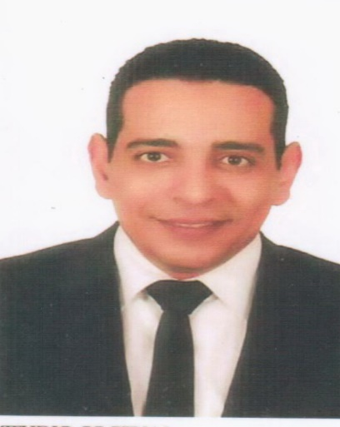 |  | EDUCATION
Ain-shams university
2019-2022
M.Sc. in environmental chemical engineering

Military technical college
1994-2000
B.Sc. in nuclear chemical engineering
mahmoud abbas  Chemical engineer  Profile  -45 years old .  -master’s degree in environmental chemical engineering,  -expert in using of radiation sources and protection from ionizing -radiation and chemical warefare,  -occupational safety and health consultant.  -internal auditor ISO9001.  -risk assessment professional.  -crisis management and negotiatiator.  CONTACT  PHONE NUMBER:  +201090775400  WEBSITE:  www.linkedin.com/in/elanadoli  EMAIL ADDRESS:  mahmoudmorsiabbas@gmail.com |  | WORK EXPERIENCE
Egy-army colonel engineer
2000-2019
-Planning, designing, building, and operating locks and dams. Other civil engineering projects include flood control, beach nourishment, and dredging for waterway navigation.
-Design and construction of flood protection systems through various federal mandates.
-Design and construction management of military facilities for the Army, Air Force, Army Reserve, and Air Force Reserve as well as other Department of Defense and federal government agencies.
-Environmental regulation and ecosystem restoration.

 |  | SKILLS
-ICDL
-occupational safety and health expert.
-quality assurance and control.
-translation from English to Arabic.
-exportation and shipping.
-dealing with hazard and nuclear materials.

